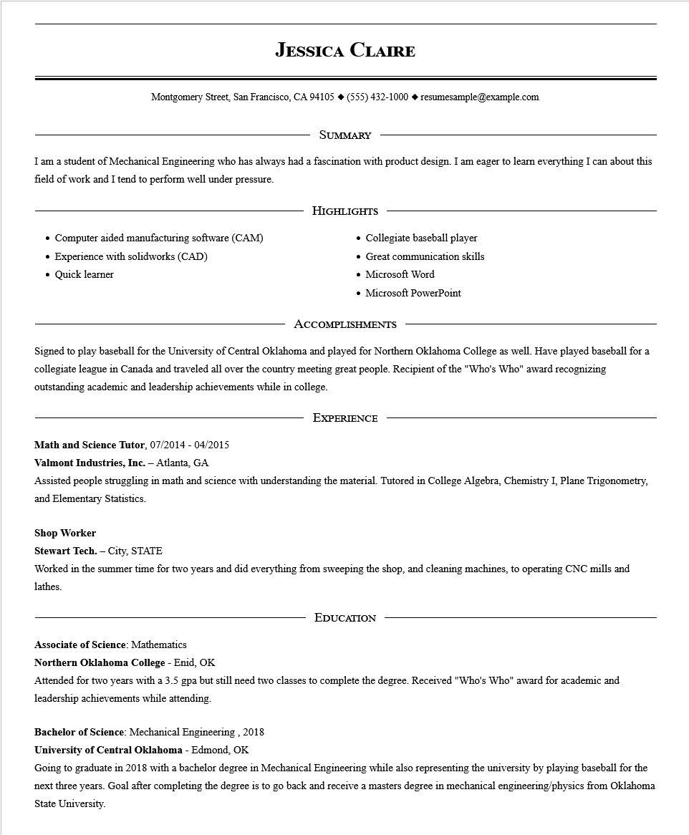
JESSICA CLAIRE
Montgomery Street, San Francisco, CA 94105 ♦ (555) 432-1000 resumesample@example.com
SUMMARY
I am a student of Mechanical Engineering who has always had a fascination with product design. I am eager to learn everything I can about this field of work and I tend to perform well under pressure.
Computer aided manufacturing software (CAM)
.
Experience with solidworks (CAD)
•
Quick learner
HIGHLIGHTS
Collegiate baseball player
• Great communication skills
• Microsoft Word
• Microsoft PowerPoint
ACCOMPLISHMENTS
Signed to play baseball for the University of Central Oklahoma and played for Northern Oklahoma College as well. Have played baseball for a collegiate league in Canada and traveled all over the country meeting great people. Recipient of the "Who's Who" award recognizing outstanding academic and leadership achievements while in college.
EXPERIENCE
Math and Science Tutor, 07/2014 - 04/2015
Valmont Industries, Inc. - Atlanta, GA
Assisted people struggling in math and science with understanding the material. Tutored in College Algebra, Chemistry I, Plane Trigonometry, and Elementary Statistics.
Shop Worker
Stewart Tech. - City, STATE
Worked in the summer time for two years and did everything from sweeping the shop, and cleaning machines, to operating CNC mills and lathes.
EDUCATION
Associate of Science: Mathematics
Northern Oklahoma College - Enid, OK
Attended for two years with a 3.5 gpa but still need two classes to complete the degree. Received "Who's Who" award for academic and leadership achievements while attending.
Bachelor of Science: Mechanical Engineering, 2018
University of Central Oklahoma - Edmond, OK
Going to graduate in 2018 with a bachelor degree in Mechanical Engineering while also representing the university by playing baseball for the
next three years. Goal after completing the degree is to go back and receive a masters degree in mechanical engineering/physics from Oklahoma State University.

